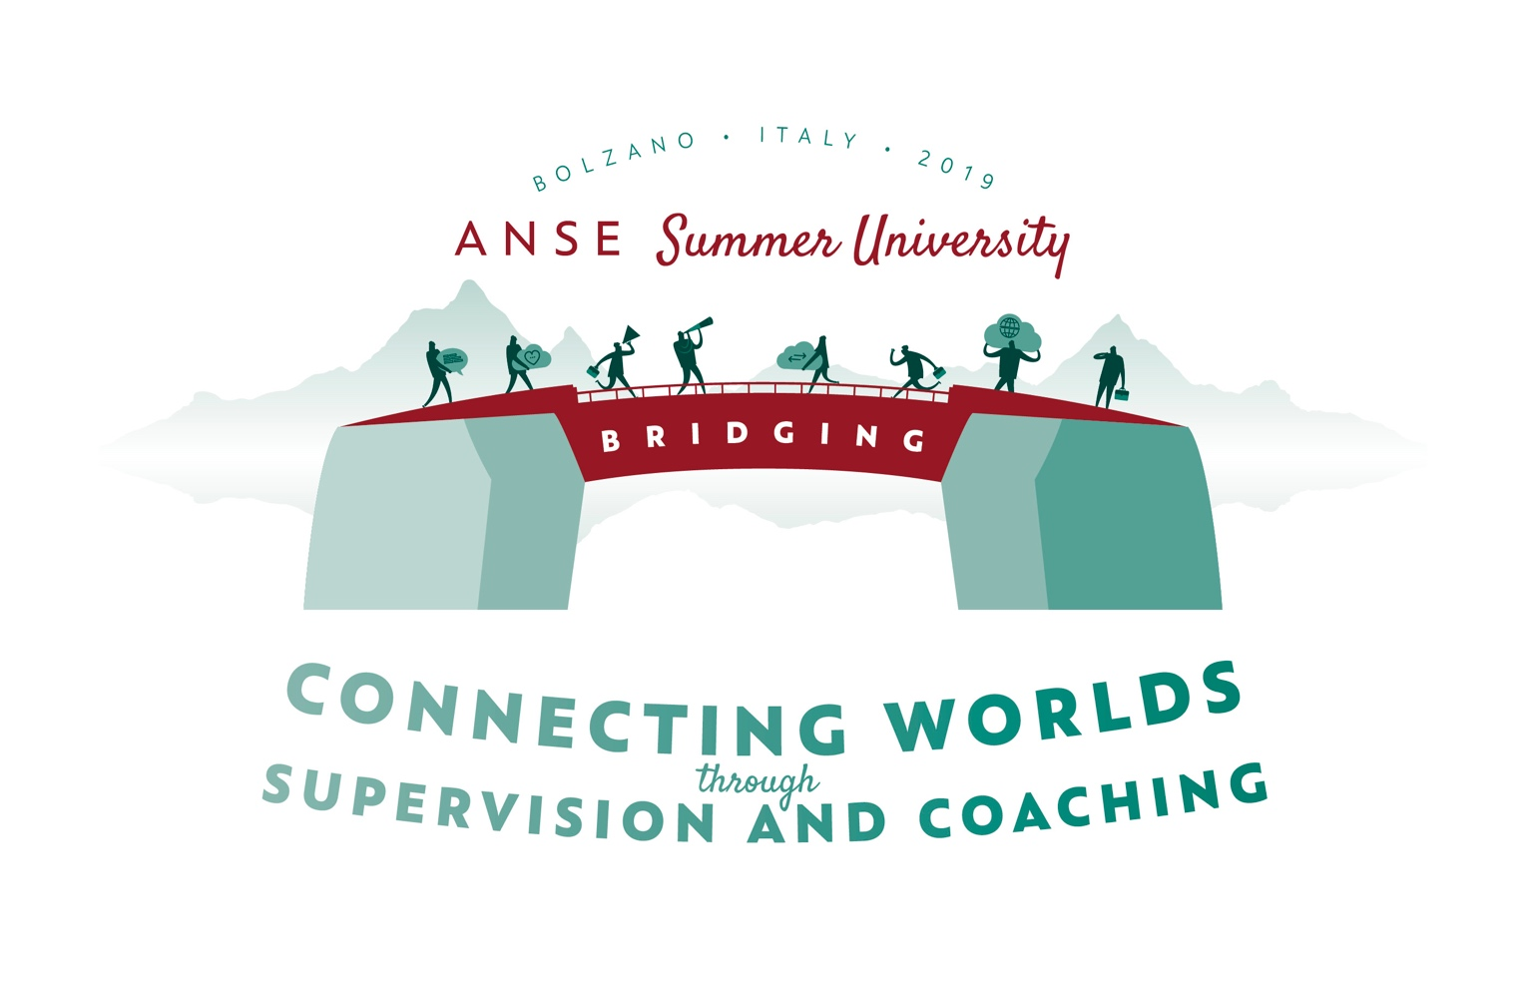

ANSE SUMMER UNIVERSITY 2019
26 - 30 August 2019, Bolzano South Tyrol Italy

“Bridging - Connecting worlds through Supervision and Coaching”

Call for SU2019 workshops is open!

We are currently planning the conference program for the ANSE Summer University which is being held in Bolzano between 26 and 30 August 2019. The main theme of the conference week will be “Bridging – connecting worlds through Supervision and Coaching”.

Bridging means to us, to explore the existential way to give shape to separation and connection as natural forces of life. Throughout history, these forces have been expressed in different ways. In today's world, division and polarization seems to prevail. On the other hand, the need and longing to unify is a strongly felt exigency.
During this week, we will explore these ambivalences, effects and observations in our working field and share concepts of bridging, approaches of integration and experiences of connecting.

We are pleased to invite you to share your experience and knowledge to our special professional meeting space.

Please send us your workshop proposal

The main language of the workshops will be English. As is the case for most of the participants at the Summer University, English may not be your native language, so no one should worry.

Exemplary aspects for your workshops:
- containing ambivalences
- integration and inclusion of groups and systems on the border
- interspaces as gaps with creative potential
- cycles of differentiation and integration as conditio humana
- connecting of proven and new
- interaction of different worlds
- exploring the common ground to grow cohesion
- effective working time will be 1,5 hours
- ……

Criteria for our workshop selection:
- experience in practical application of the concept
- connection to the main theme and the daily keynotes
- diversity and plurality:
- thematically
- geographically
- uniqueness

Procedure:
- Send your application or questions to BSC: workshop@su19.it
- The deadline for applications is 28 February 2019.
- All applicants will receive an answer by 15 March 2019.

PS: workshop leaders are not expected to pay the registration fee for the Summer University!
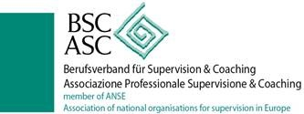
Guidelines for your application
Include information about your workshop:

Title
Maximum number of participants

Learning outcome

Workshop concept-description

Short biography (max 150 words)

Your practical experiences in application of your bridging concepts

Please note: according to regulation (EU) 2016/679 of 27 April 2016, your data will be only used for summer university contents.

